Name: Class:
Introduction
Many of the chemicals you learn about at school are substances that society uses. The questions below relate to typical carbon compounds found in many homes. Look in your laundry, garage and bathroom for the products mentioned below. Examine the labels on these products to answer the questions. The functional groups present on some of the molecules below will be more complex than is required for Chemistry Unit 2B, but your teacher should be able to assist you.

No. | Question | Answer
 | Unleaded petrol (for lawnmowers or chain saws). This is a mixture of alkanes, including 3-ethylhexane. Give the structural formula of this compound.
 | Aerosol cans. These are no longer permitted to use fluorocarbons as propellants. List examples of some aerosol products, and the propellant present (if given on the label).
 | Essences for cooking, such as lemon, vanilla and peppermint. What ingredient is common to each of these? The same ingredient is common to many cough mixtures. Why is the sale of these products occasionally under scrutiny?
Vitamin tablets. Which ingredients in these tablets sound organic? The structure of one ingredient, vitamin C, also called ascorbic acid, is shown below. Write its empirical formula.
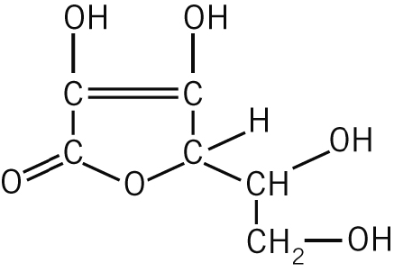
 | Sherbert, such as in Wizz Fizz, contains citric acid. This acid is also found in citrus fruits. Draw the structural formula of a citric acid molecule.
 | Fingernail polish remover. What is the active ingredient? Draw its structural formula. (Another name for it is dimethyl ketone)
 | Salad dressing, vinegar-based products and Worcestershire sauce all contain acetic acid. Sketch its structural formula.
 | Shampoo. List some of the ingredients from your shampoo that ‘sound’ organic. Can you find any of the same ingredients in other household products (such as detergents and toothpaste)?
Cooking oil and fats. Can you find the names of the fatty acids contained in these fats and oils? Stearic acid, which occurs widely in fats, has a formula C₁₇H₃₅COOH. Draw a structural formula of it.
Linolenic acid, which occurs widely in vegetable oils, is a polyunsaturated fatty acid. What does this mean?
 | Rubber can be made from 1,3-butadiene. Give the structural formula of this molecule.

